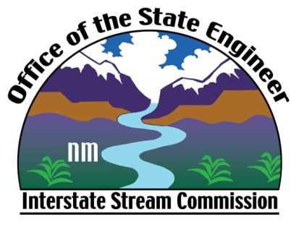

Interstate Stream Commission

Los Lunas Silvery Minnow Refugium

Tour Request Form

The Interstate Stream Commission would welcome the opportunity to provide an informational tour for your group or organization. If your group is interested, please provide the following information. You will be contacted with confirmation of your tour.

Print this form and mail or e-mail to:

Office of the State Engineer
Public Information Officer Lela Hunt
5550 San Antonio Dr NE
Albuquerque, NM 87109
(505) 383-4092

Or include all of the following information in e-mail, with “Tour Request” as the subject line, to: lela.hunt@state.nm.us

Name of Group or Organization:

Contact Person:

Contact Phone Number and E-mail address:

Preferred Date(s) Requested:

Number of tour participants:

Comments:

